Online Food Ordering and Delivery Management System

Mevin Jose
Prateek Meher K
Institutional Affiliation(s)
Database Management System : UE23CS351A

Abstract
The Online Food Ordering and Delivery Management System allows customers to order meals from various restaurants, manage current orders, and track deliveries. Restaurants can list menu items, and delivery drivers can fulfill delivery requests. The system ensures real-time updates via triggers and stored procedures, maintaining consistency and automation in order tracking

User Requirement Specifications(URS)
Purpose :
The purpose of this project is to design and implement a database system for managing food ordering, restaurant menus, and deliveries. The system automates order placement, tracking, and revenue calculation using SQL triggers, procedures, and functions.
Scope :
The system supports multiple users — customers, restaurants, and delivery drivers. It manages customer data, restaurant menus, orders, order items, and deliveries. It also provides analytical features such as total revenue, active order count, and driver earnings. The project integrates MySQL with a Tkinter GUI for a functional front-end interface.
Detailed Description :
Customers can place orders from different restaurants through the interface. Each restaurant maintains its menu, and multiple customers can order simultaneously. Once an order is placed, it’s automatically recorded in the current orders list. Triggers ensure that totals are updated whenever new order items are added. After a delivery is assigned, the system updates delivery status and calculates delivery fees. The system’s backend includes relational tables for customers, orders, order_items, restaurants, menu, deliveries, and delivery_drivers. The system also includes automation logic through SQL triggers and business logic using stored procedures and functions. A GUI interface built using Python’s Tkinter library allows users to interact with the system to place orders, assign deliveries, and view statistics.

Functional Requirements
Functionality | Description
Add new customer | Allows addition of a new customer to the system
Place new order | Places a new order for an existing customer
Add order items | Adds menu items to a customer’s order
Assign delivery | Assigns a delivery driver to an order
Calculate total order amount | Automatically updates order total using triggers
Track current orders | Shows which orders are still active
Calculate restaurant revenue | Function to compute total revenue per restaurant
Calculate driver earnings | Function to compute total earnings for a driver
GUI Integration | Tkinter interface for placing orders and assigning deliveries

Tools Used
Tool / Language | Purpose
MySQL | Database
Python | Programming language
Tkinter | GUI framework
MySQL Connector for Python | Database connectivity
SQL Workbench / phpMyAdmin | Database management
GitHub | Version control and submission repository

ER Diagram
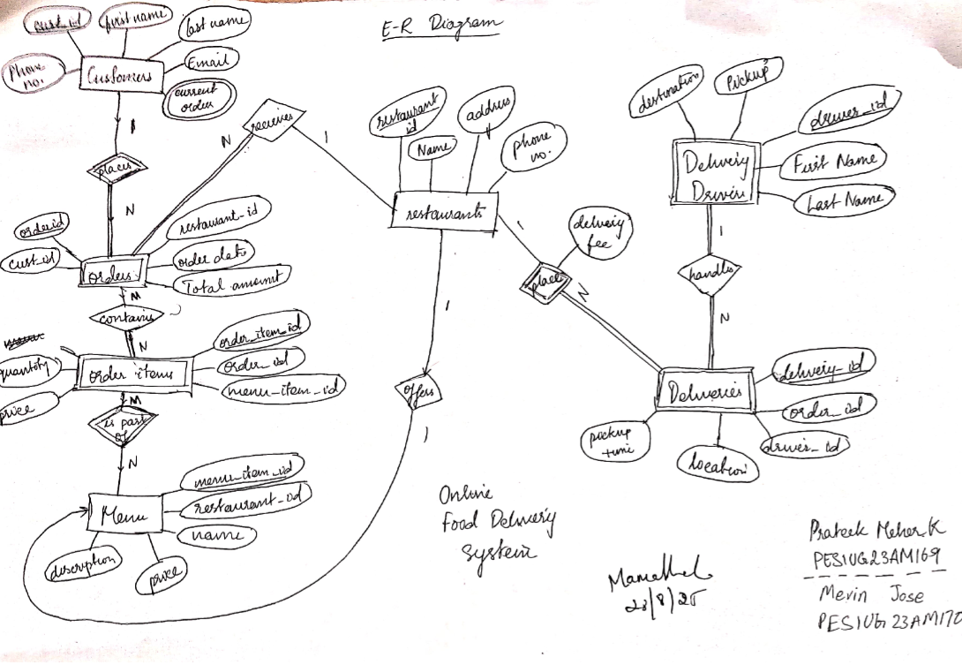

Relational Schema
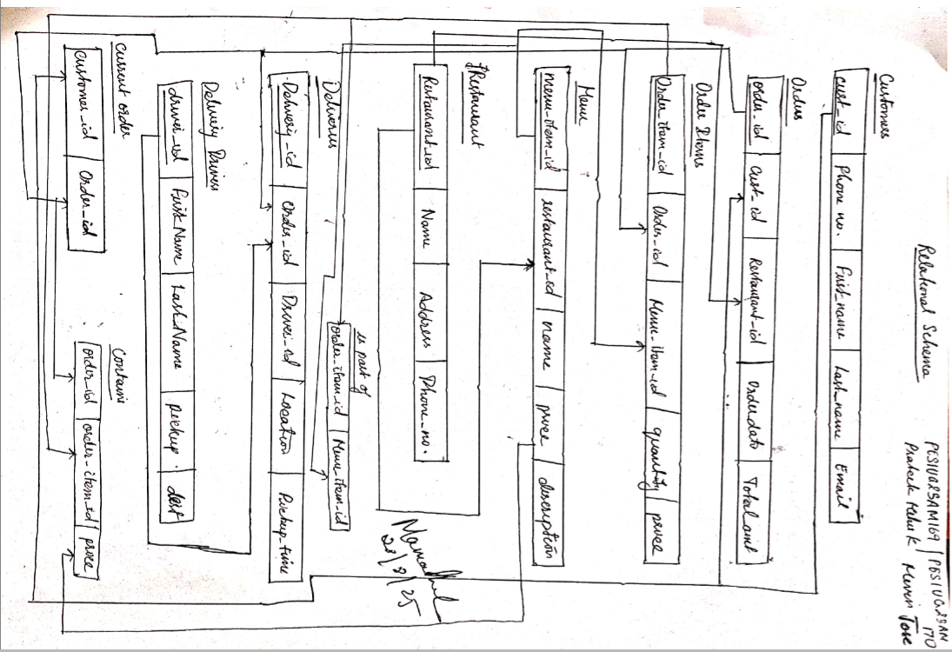
DDL Commands
-- ============================================================
-- DATABASE STRUCTURE: Online Food Ordering and Delivery System
-- ============================================================

CREATE DATABASE IF NOT EXISTS dbms_project;
USE dbms_project;

-- ============================================================
-- TABLES
-- ============================================================

-- CUSTOMERS
CREATE TABLE customers (
Customer_ID INT AUTO_INCREMENT PRIMARY KEY,
First_Name VARCHAR(50),
Last_Name VARCHAR(50),
Phone_No VARCHAR(15) UNIQUE,
Email VARCHAR(100)
);

-- RESTAURANTS
CREATE TABLE restaurants (
Restaurant_ID INT AUTO_INCREMENT PRIMARY KEY,
Name VARCHAR(100),
Address VARCHAR(255),
Phone_No VARCHAR(15)
);

-- MENU (1:1 with RESTAURANTS)
CREATE TABLE menu (
Menu_Item_ID INT AUTO_INCREMENT PRIMARY KEY,
Restaurant_ID INT UNIQUE,
Name VARCHAR(100),
Description TEXT,
Price DECIMAL(10,2),
FOREIGN KEY (Restaurant_ID) REFERENCES restaurants(Restaurant_ID)
);

-- ORDERS (Weak entity: depends on Customers and Restaurants)
CREATE TABLE orders (
Order_ID INT AUTO_INCREMENT PRIMARY KEY,
Customer_ID INT,
Restaurant_ID INT,
Order_Date DATE,
Total_Amount DECIMAL(10,2),
FOREIGN KEY (Customer_ID) REFERENCES customers(Customer_ID),
FOREIGN KEY (Restaurant_ID) REFERENCES restaurants(Restaurant_ID)
);

-- ORDER ITEMS (M:N between ORDERS and MENU)
CREATE TABLE order_items (
Order_Item_ID INT AUTO_INCREMENT PRIMARY KEY,
Order_ID INT,
Menu_Item_ID INT,
Quantity INT,
Price DECIMAL(10,2),
FOREIGN KEY (Order_ID) REFERENCES orders(Order_ID),
FOREIGN KEY (Menu_Item_ID) REFERENCES menu(Menu_Item_ID)
);

-- DELIVERY DRIVERS
CREATE TABLE delivery_drivers (
Driver_ID INT AUTO_INCREMENT PRIMARY KEY,
First_Name VARCHAR(50),
Last_Name VARCHAR(50),
Pickup VARCHAR(100),
Destination VARCHAR(100)
);

-- DELIVERIES (Weak entity: depends on Orders, Restaurants, Drivers)
CREATE TABLE deliveries (
Delivery_ID INT AUTO_INCREMENT PRIMARY KEY,
Order_ID INT,
Restaurant_ID INT,
Driver_ID INT,
Pickup_Time DATETIME,
Location VARCHAR(255),
Delivery_Fee DECIMAL(10,2),
FOREIGN KEY (Order_ID) REFERENCES orders(Order_ID),
FOREIGN KEY (Restaurant_ID) REFERENCES restaurants(Restaurant_ID),
FOREIGN KEY (Driver_ID) REFERENCES delivery_drivers(Driver_ID)
);

-- MULTIVALUED ATTRIBUTE: CUSTOMER CURRENT ORDERS
CREATE TABLE customer_current_orders (
Customer_ID INT,
Order_ID INT,
PRIMARY KEY (Customer_ID, Order_ID),
FOREIGN KEY (Customer_ID) REFERENCES customers(Customer_ID)
);

-- ============================================================
-- TRIGGERS
-- ============================================================

DELIMITER $$

-- Trigger 1: After a new order is placed → Add to current orders
CREATE TRIGGER after_order_insert
AFTER INSERT ON orders
FOR EACH ROW
BEGIN
INSERT INTO customer_current_orders (Customer_ID, Order_ID)
VALUES (NEW.Customer_ID, NEW.Order_ID);
END$$

-- Trigger 2: After adding an order item → Recalculate total
CREATE TRIGGER after_order_item_insert
AFTER INSERT ON order_items
FOR EACH ROW
BEGIN
UPDATE orders
SET Total_Amount = (
SELECT COALESCE(SUM(Price), 0)
FROM order_items
WHERE Order_ID = NEW.Order_ID
)
WHERE Order_ID = NEW.Order_ID;
END$$

-- Trigger 3: After a delivery is completed → Remove from current orders
CREATE TRIGGER after_delivery_insert
AFTER INSERT ON deliveries
FOR EACH ROW
BEGIN
DELETE FROM customer_current_orders
WHERE Order_ID = NEW.Order_ID;
END$$

DELIMITER ;

-- ============================================================
-- STORED PROCEDURES
-- ============================================================

DELIMITER $$

-- Procedure: Place a new order
CREATE PROCEDURE PlaceOrder(
IN p_customer_id INT,
IN p_restaurant_id INT,
IN p_order_date DATE,
IN p_menu_item_id INT,
IN p_quantity INT
)
BEGIN
DECLARE v_order_id INT;
DECLARE v_price DECIMAL(10,2);

SELECT Price INTO v_price
FROM menu
WHERE Menu_Item_ID = p_menu_item_id;

INSERT INTO orders (Customer_ID, Restaurant_ID, Order_Date, Total_Amount)
VALUES (p_customer_id, p_restaurant_id, p_order_date, 0.00);

SET v_order_id = LAST_INSERT_ID();

INSERT INTO order_items (Order_ID, Menu_Item_ID, Quantity, Price)
VALUES (v_order_id, p_menu_item_id, p_quantity, v_price * p_quantity);
END$$

-- Procedure: Assign a delivery to a driver
CREATE PROCEDURE AssignDelivery(
IN p_order_id INT,
IN p_restaurant_id INT,
IN p_driver_id INT,
IN p_location VARCHAR(255),
IN p_fee DECIMAL(10,2)
)
BEGIN
INSERT INTO deliveries (Order_ID, Restaurant_ID, Driver_ID, Pickup_Time, Location, Delivery_Fee)
VALUES (p_order_id, p_restaurant_id, p_driver_id, NOW(), p_location, p_fee);
END$$

DELIMITER ;

DELIMITER $$

-- Function 1: Get active order count per customer
CREATE FUNCTION GetActiveOrderCount(p_customer_id INT)
RETURNS INT
DETERMINISTIC
BEGIN
DECLARE cnt INT;
SELECT COUNT(*) INTO cnt
FROM customer_current_orders
WHERE Customer_ID = p_customer_id;
RETURN cnt;
END$$

-- Function 2: Get total revenue of a restaurant
CREATE FUNCTION GetRestaurantRevenue(p_restaurant_id INT)
RETURNS DECIMAL(10,2)
DETERMINISTIC
BEGIN
DECLARE total DECIMAL(10,2);
SELECT COALESCE(SUM(Total_Amount), 0)
INTO total
FROM orders
WHERE Restaurant_ID = p_restaurant_id;
RETURN total;
END$$

-- Function 3: Get total earnings of a delivery driver
CREATE FUNCTION GetDriverEarnings(p_driver_id INT)
RETURNS DECIMAL(10,2)
DETERMINISTIC
BEGIN
DECLARE total DECIMAL(10,2);
SELECT COALESCE(SUM(Delivery_Fee), 0)
INTO total
FROM deliveries
WHERE Driver_ID = p_driver_id;
RETURN total;
END$$

DELIMITER ;

CRUD Operations Screenshots
Create
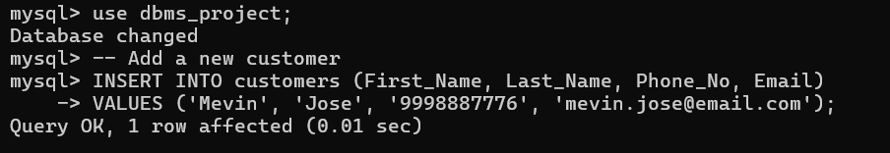
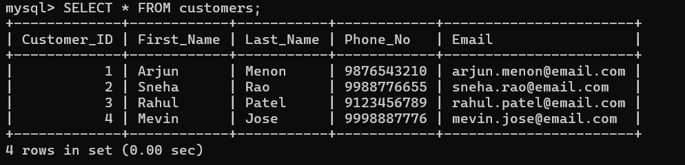
Insert
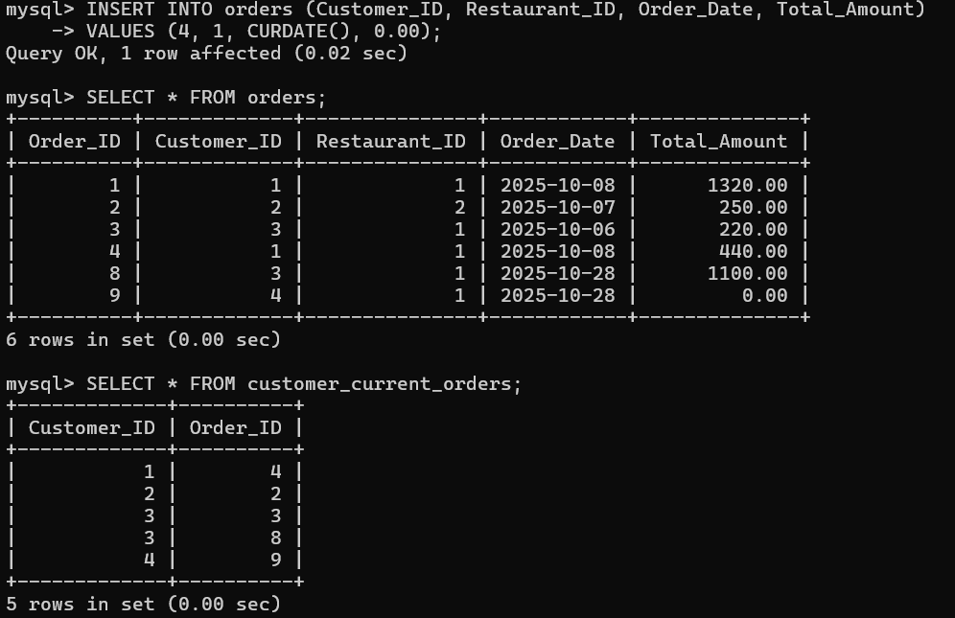
This demonstrates inserting into orders table and triggers (after_order_insert) firing automatically to add it into customer_current_orders
Update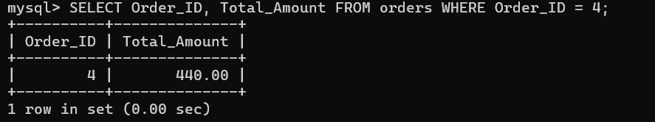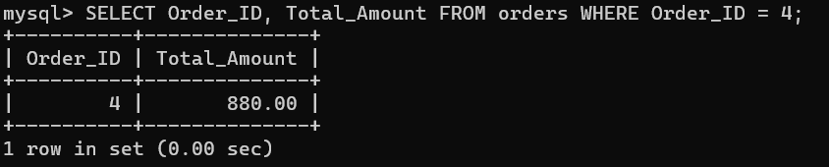
This tests the after_order_item_insert trigger, which automatically updates Total_Amount in orders
Delete
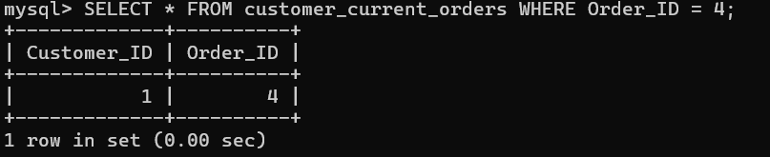
This tests the after_delivery_insert trigger, which removes the completed order from customer_current_orders

List of functionalities/features of the application and its associated screenshots using
front end

This Food Delivery Admin web application provides a complete backend-driven interface for managing customers, restaurants, menu items, orders and deliveries. It pairs a MySQL schema (DDL, triggers, stored procedures and functions) with a Bootstrap-based Flask front end so admins can create, read, update and delete data, place orders, and assign deliveries — plus view summarized reports.
Core features (what the application does)
- Dashboard
  - Role: Quick overview of system state (counts for orders, deliveries, drivers, restaurants).
  - Why: Rapid status checks for admins.
  - Screenshot:
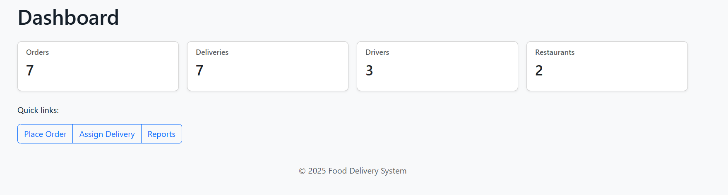
- Customers management (full CRUD)
  - Role: Add, edit, delete and list customers. Stores first/last name, phone, email.
  - Why: Keep customer base up to date and correct contact data.
  - Screenshots:
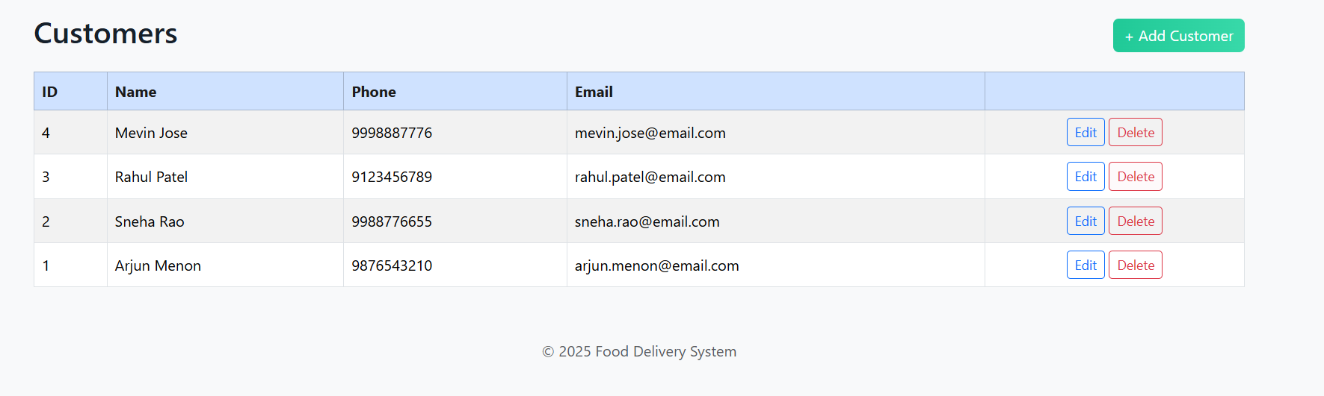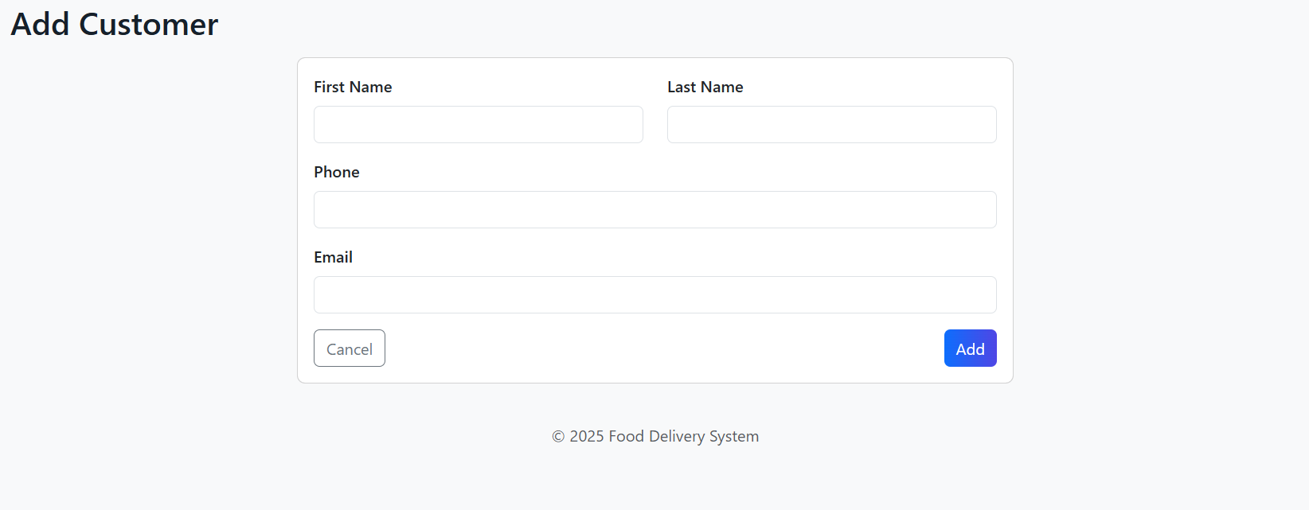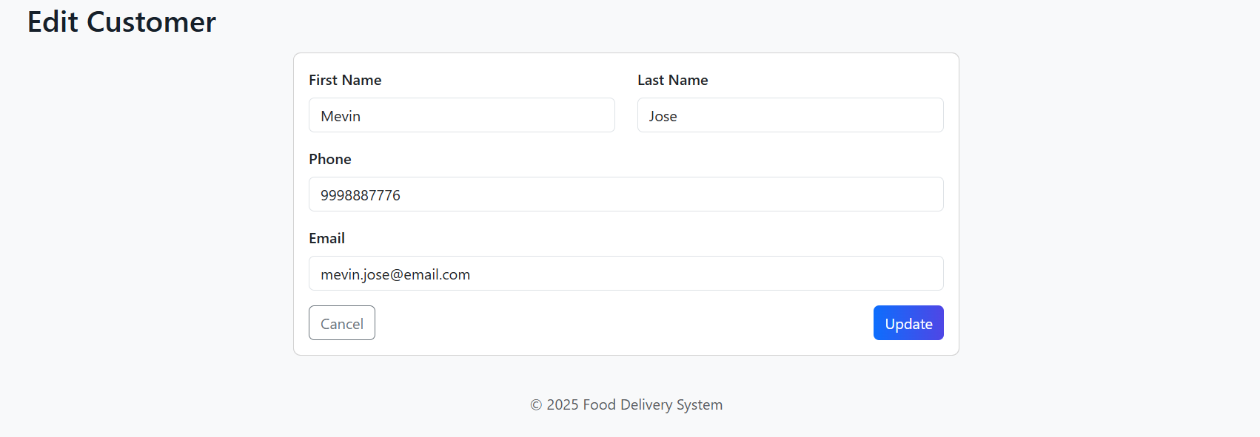
- Restaurants management (full CRUD)
  - Role: Maintain restaurant records (name, address, phone).
  - Why: Required to link orders and menus to restaurants.
  - Screenshots:
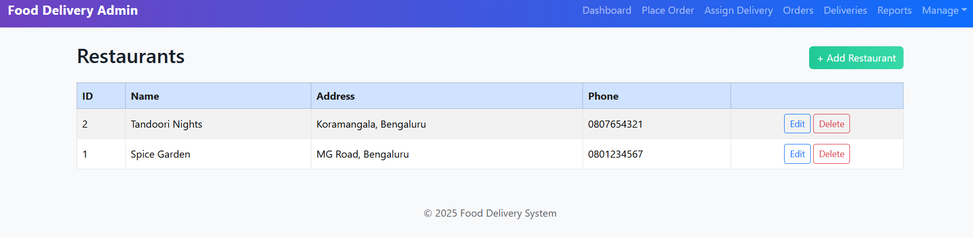
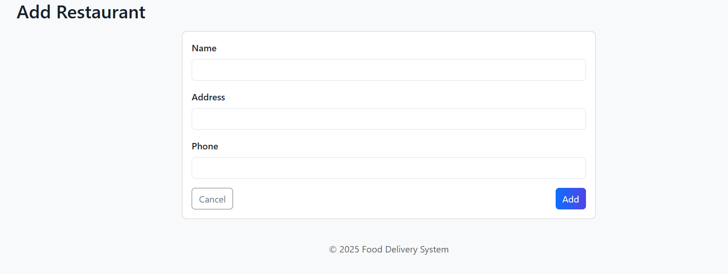Menu items management (full CRUD)
  - Role: Create and modify menu items tied to restaurants (name, description, price).
  - Why: Menu drives order creation and price calculations.
  - Screenshots:
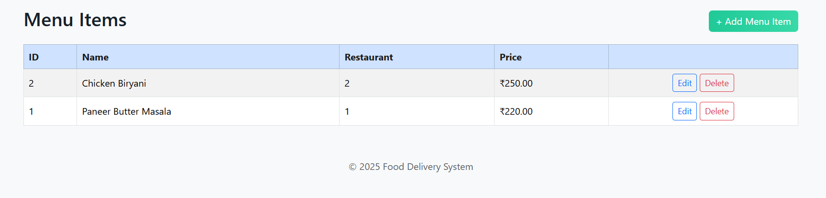
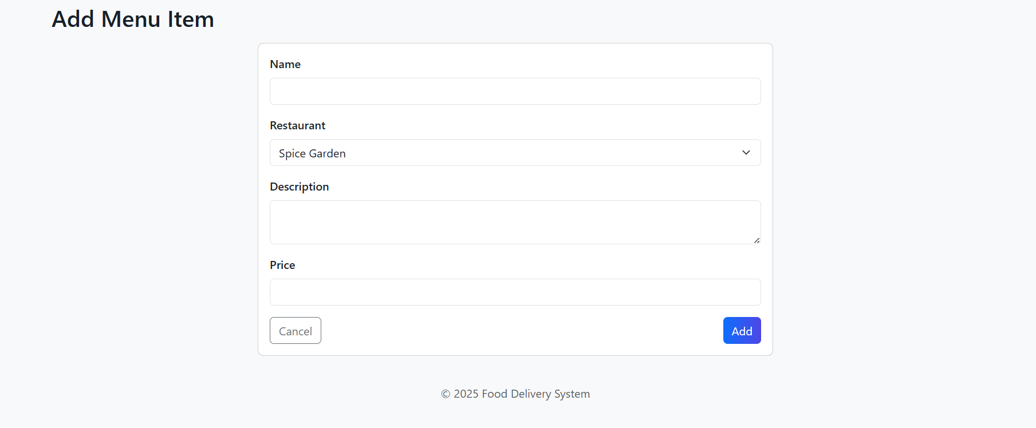
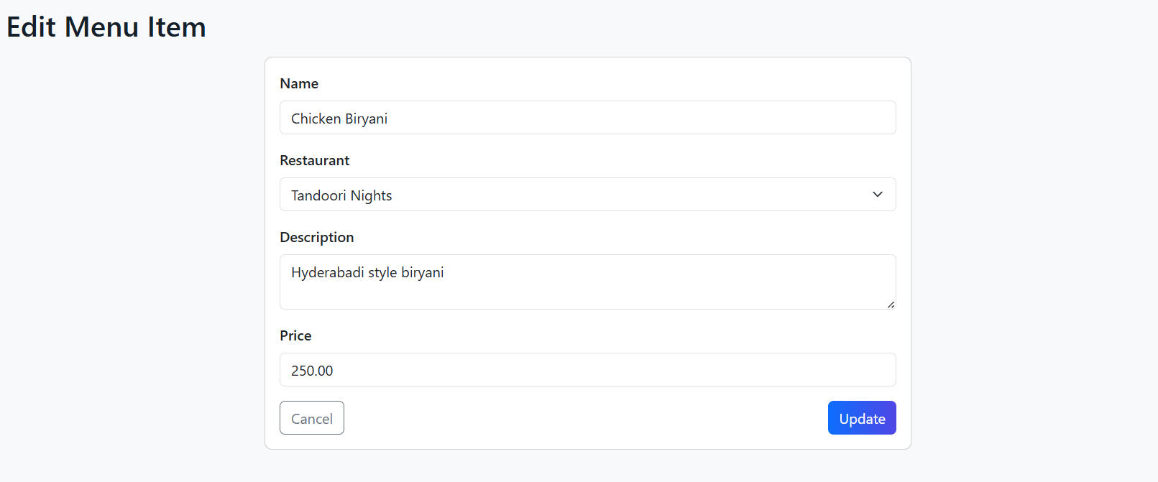Delivery drivers management (full CRUD)
  - Role: Add, edit, and remove drivers, store pickup/destination info.
  - Why: Assign drivers to deliveries, track availability.
  - Screenshot:
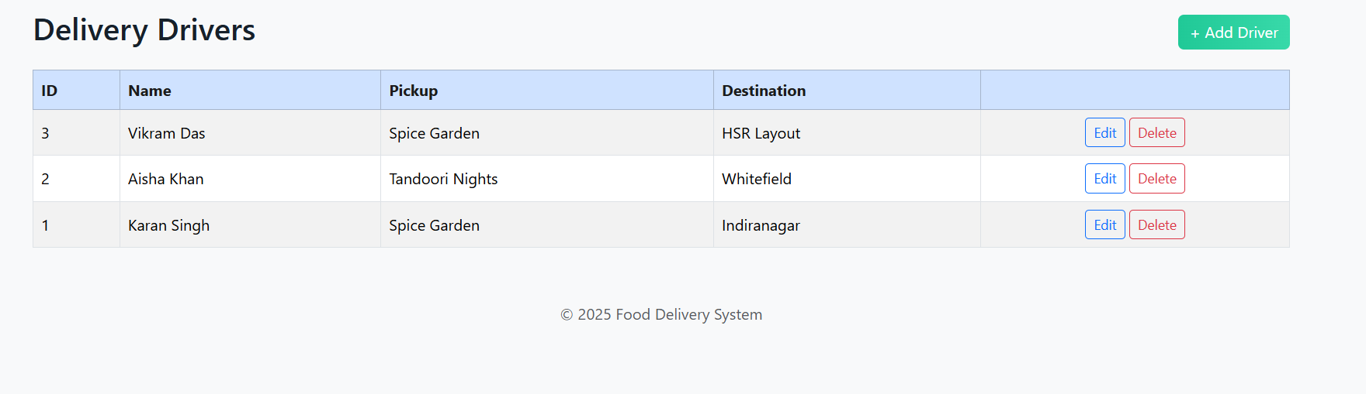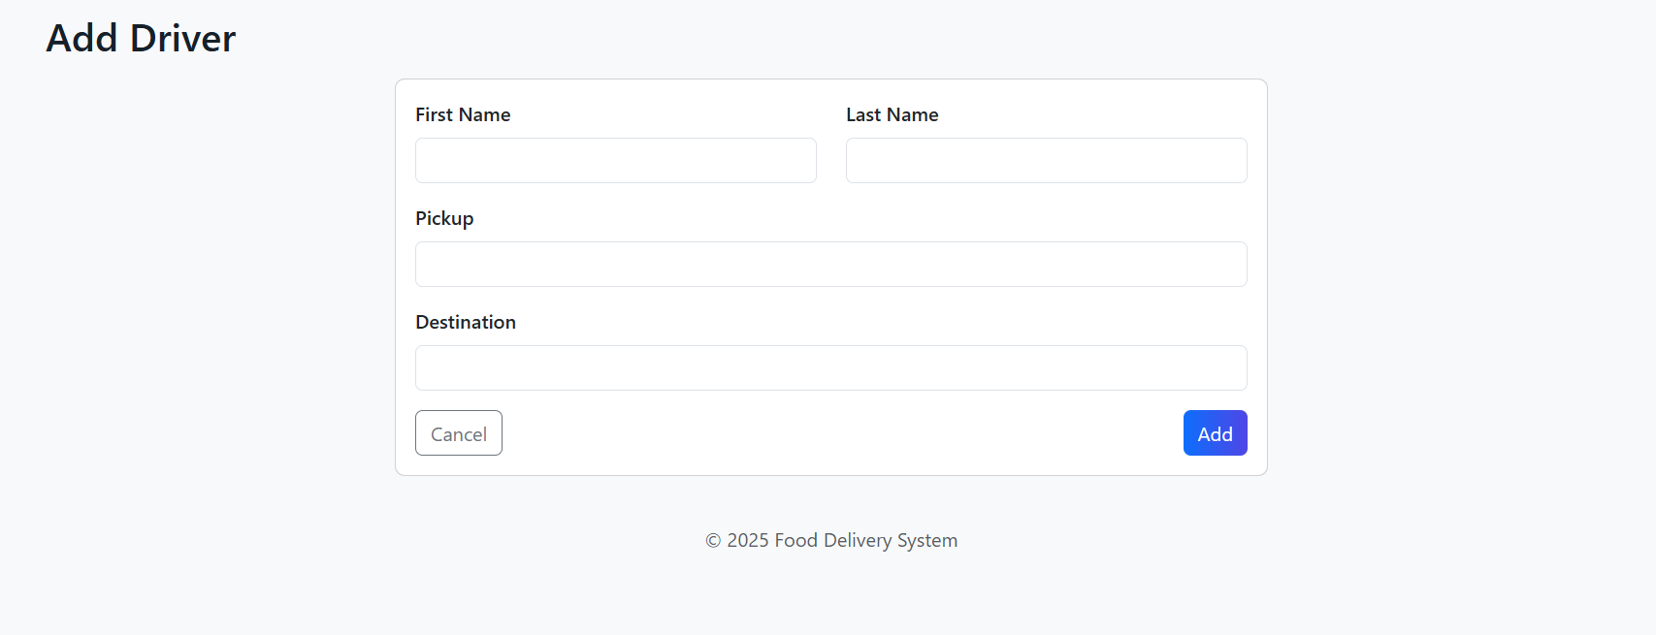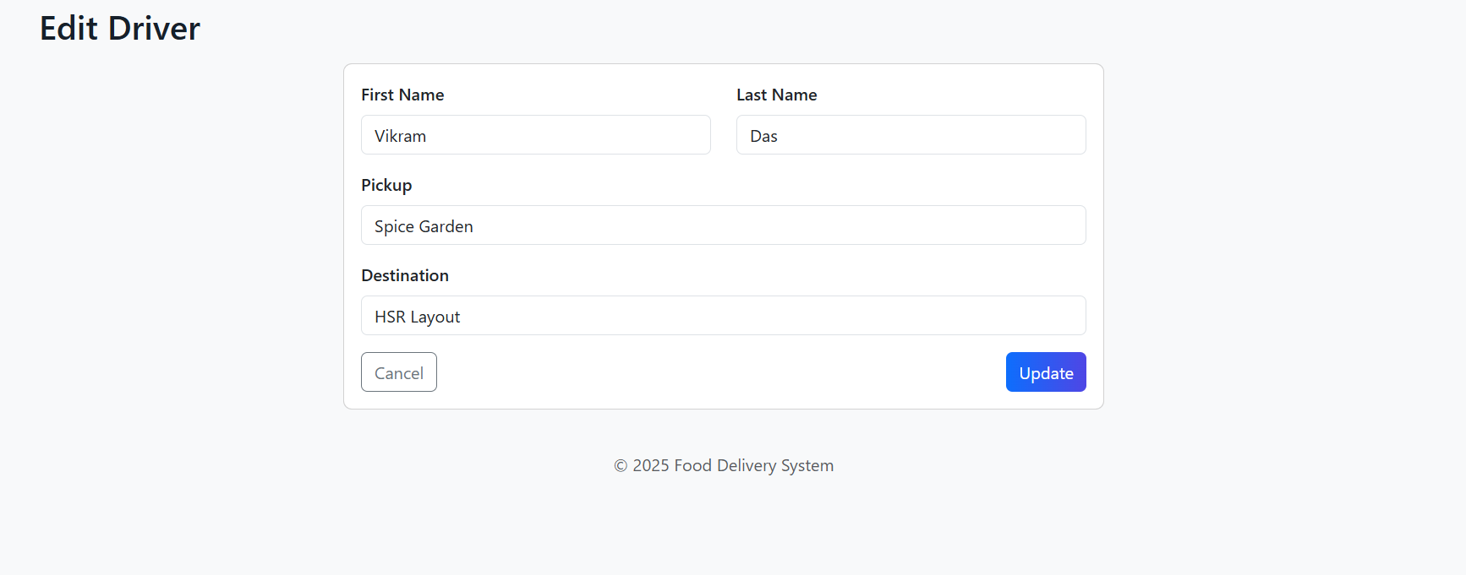
- Place Order (uses stored procedure)
  - Role: Create an order by selecting a customer, restaurant and menu item; invokes the PlaceOrder stored procedure.
  - Why: Demonstrates embedding stored procedures in the app and triggers to maintain totals/current orders.
  - Screenshot:
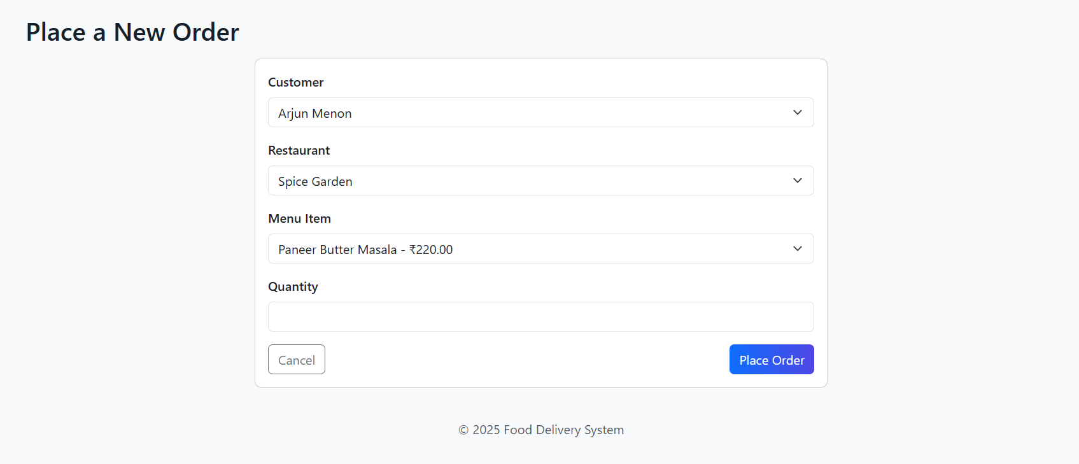
- Assign Delivery (uses stored procedure)
  - Role: Assign a driver and fee to an order; calls AssignDelivery stored procedure which inserts a delivery record.
  - Why: Demonstrates delivery workflow and trigger that removes order from current orders after delivery.
  - Screenshot:
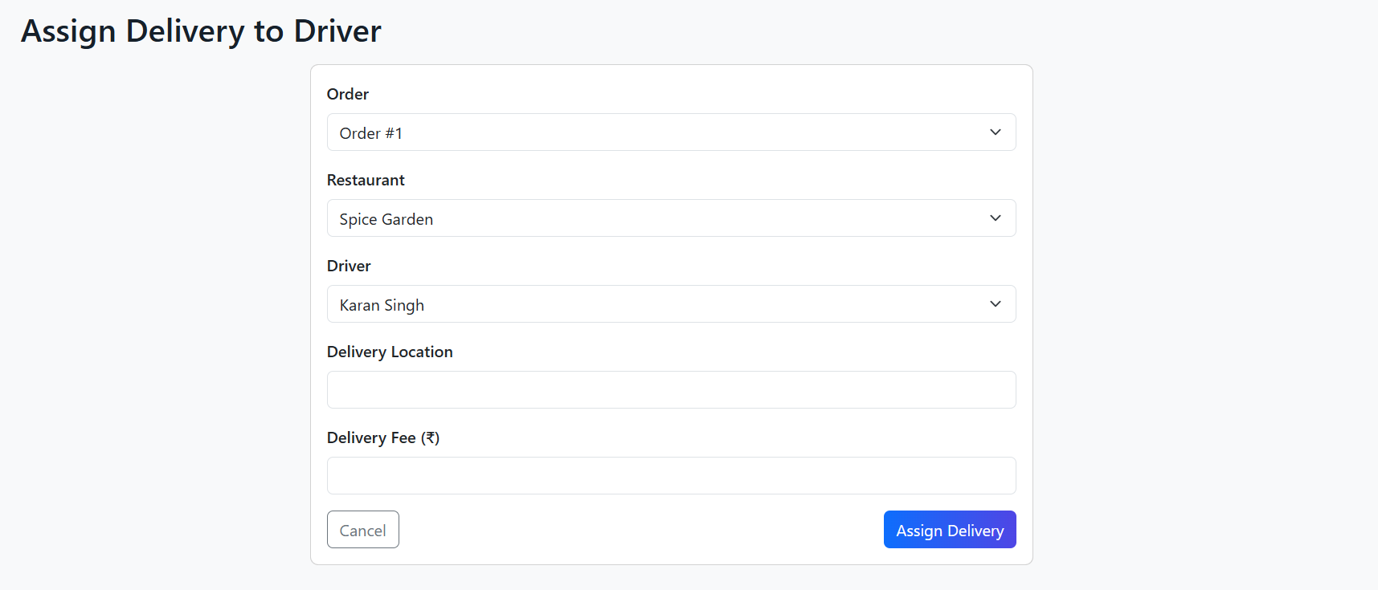
- Orders list & order details
  - Role: Browse orders, search by order or customer name; inspect order detail with items and delivery records.
  - Why: Review order lifecycle; troubleshooting and audit.
  - Screenshots:
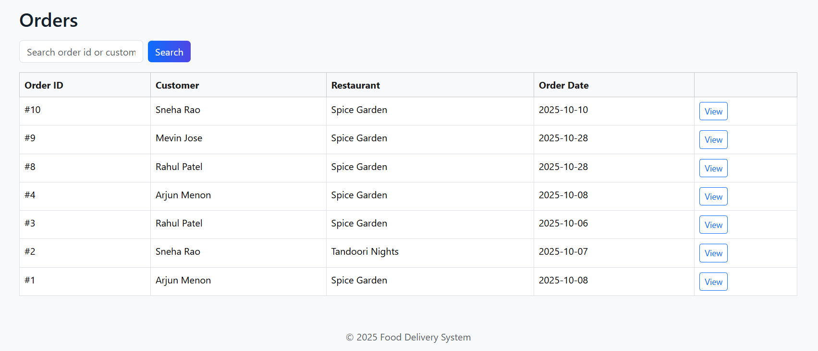 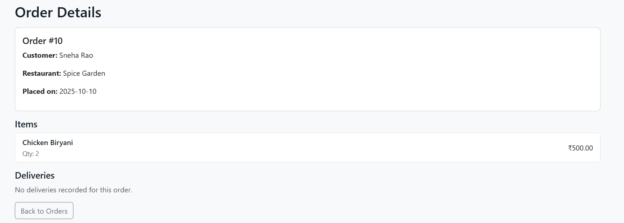Deliveries view
  - Role: View active/completed deliveries with pickup time, location and the customer/restaurant context.
  - Why: Monitor delivery status and historic deliveries.
  - Screenshot:
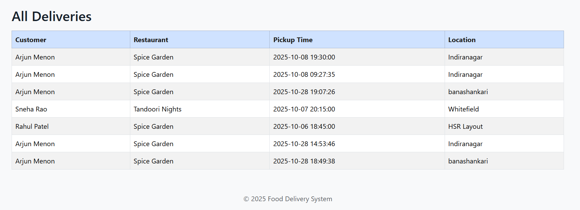
- Reports & analytics (DB functions)
  - Role: Run functions like GetActiveOrderCount and GetRestaurantRevenue to show summarized metrics.
  - Why: Demonstrates complex DB logic exposed via the front end.
  - Screenshot:
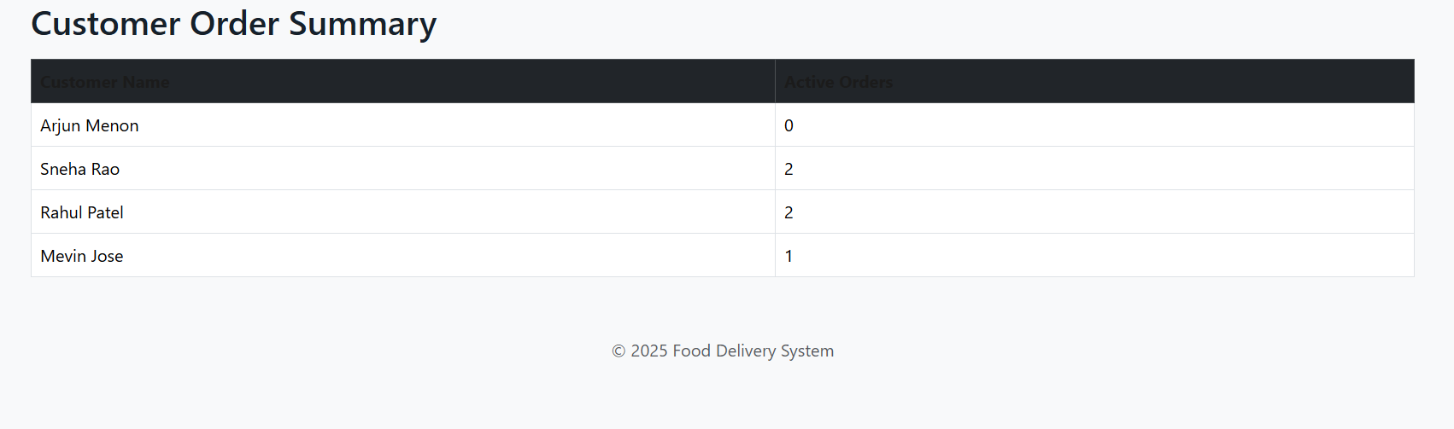
Interface & UX improvements
- Responsive Bootstrap layout with a colorful gradient header and card accents to improve visual hierarchy.
- Flash messages and confirmations for create/update/delete actions.
- Consistent forms (single-column cards for focused input) and table views with action buttons.

Triggers, Procedures/Functions, Nested query, Join, Aggregate queries
Triggers
- after_order_insert – Adds new orders automatically to Customer_Current_Orders.
- after_order_item_insert – Updates total amount whenever an item is added.
- after_delivery_insert – Removes order from current orders once delivery is assigned.
Stored Procedures
- PlaceOrder – Places a new order for a customer and adds order items automatically.
- AssignDelivery – Assigns delivery to a driver with pickup details and fee.
Functions
- GetActiveOrderCount – Returns number of active orders for a customer.
- GetRestaurantRevenue – Returns total revenue for a given restaurant.
- GetDriverEarnings – Returns total earnings for a specific driver.
Nested, Join, and Aggregate Queries
Nested Query Example
-- Display customers who have placed more than one order
SELECT Customer_ID, First_Name, Last_Name
FROM customers
WHERE Customer_ID IN (
SELECT Customer_ID
FROM orders
GROUP BY Customer_ID
HAVING COUNT(Order_ID) > 1
);

Join Query Example
-- Show customer name, restaurant name, and pickup time for each delivery
SELECT c.First_Name, c.Last_Name, r.Name AS Restaurant_Name, d.Pickup_Time
FROM deliveries d
JOIN orders o ON d.Order_ID = o.Order_ID
JOIN customers c ON o.Customer_ID = c.Customer_ID
JOIN restaurants r ON o.Restaurant_ID = r.Restaurant_ID;

Aggregate Query Examples
-- Total revenue generated by each restaurant
SELECT r.Name AS Restaurant, SUM(o.Total_Amount) AS Total_Revenue
FROM restaurants r
JOIN orders o ON r.Restaurant_ID = o.Restaurant_ID
GROUP BY r.Restaurant_ID;

-- Total number of deliveries handled by each driver
SELECT d.Driver_ID, dd.First_Name, dd.Last_Name, COUNT(*) AS Deliveries_Completed
FROM deliveries d
JOIN delivery_drivers dd ON d.Driver_ID = dd.Driver_ID
GROUP BY d.Driver_ID;

Code snippets for invoking the Procedures/Functions/Trigger
Invoke Stored Procedure (Place Order)
CALL PlaceOrder(1, 1, CURDATE(), 1, 2);

Invoke Stored Procedure (Assign Delivery)
CALL AssignDelivery(5, 1, 2, 'Whitefield', 45.00);
Invoke Functions
SELECT GetActiveOrderCount(1) AS Active_Orders;
SELECT GetRestaurantRevenue(1) AS Restaurant_Revenue;
SELECT GetDriverEarnings(2) AS Driver_Earnings;
Trigger Demonstration Queries
Trigger after_order_insert
INSERT INTO orders (Customer_ID, Restaurant_ID, Order_Date, Total_Amount)
VALUES (1, 1, CURDATE(), 0.00);
SELECT * FROM Customer_Current_Orders;
Trigger after_order_item_insert
INSERT INTO order_items (Order_ID, Menu_Item_ID, Quantity, Price)
VALUES (1, 1, 2, 440.00);
SELECT * FROM orders WHERE Order_ID = 1;
Trigger after_delivery_insert
INSERT INTO deliveries (Order_ID, Restaurant_ID, Driver_ID, Pickup_Time, Location, Delivery_Fee)
VALUES (1, 1, 1, NOW(), 'HSR Layout', 35.00);
SELECT * FROM Customer_Current_Orders;

SQL queries(Create, Insert, Triggers, Procedures/Functions, Nested query, Join,
Aggregate queries ) used in the project in the form of .sql file

CREATE DATABASE IF NOT EXISTS dbms_project;
USE dbms_project;
CREATE TABLE customers (
Customer_ID INT AUTO_INCREMENT PRIMARY KEY,
First_Name VARCHAR(50),
Last_Name VARCHAR(50),
Phone_No VARCHAR(15) UNIQUE,
Email VARCHAR(100)
);
CREATE TABLE restaurants (
Restaurant_ID INT AUTO_INCREMENT PRIMARY KEY,
Name VARCHAR(100),
Address VARCHAR(255),
Phone_No VARCHAR(15)
);
CREATE TABLE menu (
Menu_Item_ID INT AUTO_INCREMENT PRIMARY KEY,
Restaurant_ID INT UNIQUE,
Name VARCHAR(100),
Description TEXT,
Price DECIMAL(10,2),
FOREIGN KEY (Restaurant_ID) REFERENCES restaurants(Restaurant_ID)
);
CREATE TABLE orders (
Order_ID INT AUTO_INCREMENT PRIMARY KEY,
Customer_ID INT,
Restaurant_ID INT,
Order_Date DATE,
Total_Amount DECIMAL(10,2),
FOREIGN KEY (Customer_ID) REFERENCES customers(Customer_ID),
FOREIGN KEY (Restaurant_ID) REFERENCES restaurants(Restaurant_ID)
);
CREATE TABLE order_items (
Order_Item_ID INT AUTO_INCREMENT PRIMARY KEY,
Order_ID INT,
Menu_Item_ID INT,
Quantity INT,
Price DECIMAL(10,2),
FOREIGN KEY (Order_ID) REFERENCES orders(Order_ID),
FOREIGN KEY (Menu_Item_ID) REFERENCES menu(Menu_Item_ID)
);
CREATE TABLE delivery_drivers (
Driver_ID INT AUTO_INCREMENT PRIMARY KEY,
First_Name VARCHAR(50),
Last_Name VARCHAR(50),
Pickup VARCHAR(100),
Destination VARCHAR(100)
);
CREATE TABLE deliveries (
Delivery_ID INT AUTO_INCREMENT PRIMARY KEY,
Order_ID INT,
Restaurant_ID INT,
Driver_ID INT,
Pickup_Time DATETIME,
Location VARCHAR(255),
Delivery_Fee DECIMAL(10,2),
FOREIGN KEY (Order_ID) REFERENCES orders(Order_ID),
FOREIGN KEY (Restaurant_ID) REFERENCES restaurants(Restaurant_ID),
FOREIGN KEY (Driver_ID) REFERENCES delivery_drivers(Driver_ID)
);
CREATE TABLE customer_current_orders (
Customer_ID INT,
Order_ID INT,
PRIMARY KEY (Customer_ID, Order_ID),
FOREIGN KEY (Customer_ID) REFERENCES customers(Customer_ID)
);
INSERT INTO customers (First_Name, Last_Name, Phone_No, Email)
VALUES
('Arjun', 'Menon', '9876543210', 'arjun.menon@email.com'),
('Sneha', 'Rao', '9988776655', 'sneha.rao@email.com'),
('Rahul', 'Patel', '9123456789', 'rahul.patel@email.com');
INSERT INTO restaurants (Name, Address, Phone_No)
VALUES
('Spice Garden', 'MG Road, Bengaluru', '0801234567'),
('Tandoori Nights', 'Koramangala, Bengaluru', '0807654321');
INSERT INTO menu (Restaurant_ID, Name, Description, Price)
VALUES
(1, 'Paneer Butter Masala', 'Creamy cottage cheese curry', 220.00),
(2, 'Chicken Biryani', 'Hyderabadi style biryani', 250.00);
INSERT INTO delivery_drivers (First_Name, Last_Name, Pickup, Destination)
VALUES
('Karan', 'Singh', 'Spice Garden', 'Indiranagar'),
('Aisha', 'Khan', 'Tandoori Nights', 'Whitefield'),
('Vikram', 'Das', 'Spice Garden', 'HSR Layout');
INSERT INTO orders (Customer_ID, Restaurant_ID, Order_Date, Total_Amount)
VALUES
(1, 1, '2025-10-08', 440.00),
(2, 2, '2025-10-07', 250.00),
(3, 1, '2025-10-06', 220.00);
INSERT INTO order_items (Order_ID, Menu_Item_ID, Quantity, Price)
VALUES
(1, 1, 2, 440.00),
(2, 2, 1, 250.00),
(3, 1, 1, 220.00);

INSERT INTO customer_current_orders (Customer_ID, Order_ID)
VALUES
(1, 1),
(2, 2),
(3, 3);

DELIMITER $$
CREATE TRIGGER after_order_insert
AFTER INSERT ON orders
FOR EACH ROW
BEGIN
INSERT INTO Customer_Current_Orders (Customer_ID, Order_ID)
VALUES (NEW.Customer_ID, NEW.Order_ID);
END $$

CREATE TRIGGER after_order_item_insert
AFTER INSERT ON order_items
FOR EACH ROW
BEGIN
UPDATE Orders
SET Total_Amount = (
SELECT COALESCE(SUM(Price), 0)
FROM Order_Items
WHERE Order_ID = NEW.Order_ID
)
WHERE Order_ID = NEW.Order_ID;
END $$

CREATE TRIGGER after_delivery_insert
AFTER INSERT ON deliveries
FOR EACH ROW
BEGIN
DELETE FROM Customer_Current_Orders
WHERE Order_ID = NEW.Order_ID;
END $$
DELIMITER ;

DELIMITER $$
CREATE PROCEDURE PlaceOrder(
IN p_customer_id INT,
IN p_restaurant_id INT,
IN p_order_date DATE,
IN p_menu_item_id INT,
IN p_quantity INT
)
BEGIN
DECLARE v_order_id INT;
DECLARE v_price DECIMAL(10,2);

SELECT Price INTO v_price
FROM Menu
WHERE Menu_Item_ID = p_menu_item_id;

INSERT INTO Orders (Customer_ID, Restaurant_ID, Order_Date, Total_Amount)
VALUES (p_customer_id, p_restaurant_id, p_order_date, 0.00);

SET v_order_id = LAST_INSERT_ID();

INSERT INTO Order_Items (Order_ID, Menu_Item_ID, Quantity, Price)
VALUES (v_order_id, p_menu_item_id, p_quantity, v_price * p_quantity);
END $$

CREATE PROCEDURE AssignDelivery(
IN p_order_id INT,
IN p_restaurant_id INT,
IN p_driver_id INT,
IN p_location VARCHAR(255),
IN p_fee DECIMAL(10,2)
)
BEGIN
INSERT INTO Deliveries (Order_ID, Restaurant_ID, Driver_ID, Pickup_Time, Location, Delivery_Fee)
VALUES (p_order_id, p_restaurant_id, p_driver_id, NOW(), p_location, p_fee);
END $$

DELIMITER ;

DELIMITER $$
CREATE FUNCTION GetActiveOrderCount(p_customer_id INT)
RETURNS INT
DETERMINISTIC
BEGIN
DECLARE cnt INT;
SELECT COUNT(*) INTO cnt
FROM Customer_Current_Orders
WHERE Customer_ID = p_customer_id;
RETURN cnt;
END $$

CREATE FUNCTION GetRestaurantRevenue(p_restaurant_id INT)
RETURNS DECIMAL(10,2)
DETERMINISTIC
BEGIN
DECLARE total DECIMAL(10,2);
SELECT COALESCE(SUM(Total_Amount), 0)
INTO total
FROM Orders
WHERE Restaurant_ID = p_restaurant_id;
RETURN total;
END $$

CREATE FUNCTION GetDriverEarnings(p_driver_id INT)
RETURNS DECIMAL(10,2)
DETERMINISTIC
BEGIN
DECLARE total DECIMAL(10,2);
SELECT COALESCE(SUM(Delivery_Fee), 0)
INTO total
FROM Deliveries
WHERE Driver_ID = p_driver_id;
RETURN total;
END $$

DELIMITER ;

-- Nested Query
SELECT Customer_ID, First_Name, Last_Name
FROM customers
WHERE Customer_ID IN (
SELECT Customer_ID
FROM orders
GROUP BY Customer_ID
HAVING COUNT(Order_ID) > 1
);

-- Join Query
SELECT c.First_Name, c.Last_Name, r.Name AS Restaurant_Name, d.Pickup_Time
FROM deliveries d
JOIN orders o ON d.Order_ID = o.Order_ID
JOIN customers c ON o.Customer_ID = c.Customer_ID
JOIN restaurants r ON o.Restaurant_ID = r.Restaurant_ID;

-- Aggregate Query 1
SELECT r.Name AS Restaurant, SUM(o.Total_Amount) AS Total_Revenue
FROM restaurants r
JOIN orders o ON r.Restaurant_ID = o.Restaurant_ID
GROUP BY r.Restaurant_ID;

-- Aggregate Query 2
SELECT d.Driver_ID, dd.First_Name, dd.Last_Name, COUNT(*) AS Deliveries_Completed
FROM deliveries d
JOIN delivery_drivers dd ON d.Driver_ID = dd.Driver_ID
GROUP BY d.Driver_ID;
CALL PlaceOrder(1, 1, CURDATE(), 1, 2);
CALL AssignDelivery(1, 1, 2, 'Indiranagar', 40.00);

SELECT GetActiveOrderCount(1);
SELECT GetRestaurantRevenue(1);
SELECT GetDriverEarnings(1);

Github repo link:

https://github.com/MJenius/DBMS-Project

